**Financial Analysis/Projection;**

To successfully deliver this project/product a lot of factors must be taken into consideration, given the fact that this is not just a normal project with tangible expenses and fixed cost but one where costs fluctuate due to maintenance fees, boosted security, future developments and on-going developments

A financial projection focuses on giving a comprehensive analysis of the financial aspect of developing and launching a project and ensuring that an informed decision is made

**Cost Estimation**

* An estimation will be made with hypothetical values to give an understanding of what needs to be done and how much it will cost.

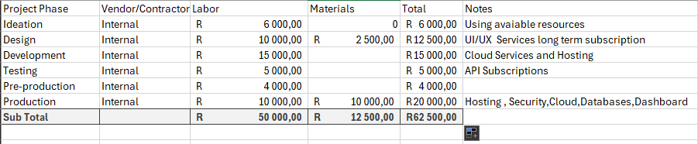

Figure 1 Cost Estimate

As seen of (Figure 1) , we are focusing on estimating costs per deliverable rather than hours and which are subjected to changed depending on what is discovered on the ideas. The following costs were not included due to needing to plan on what needs to be used, Licensing Fees for Third Party Services, Salaries to Maintenance Developers and On-going Development for adding new features and improvements.

Upon finishing a feasibility study , a more comprehensive financial projection will be creating , factoring Revenue as well as Return of Investment.